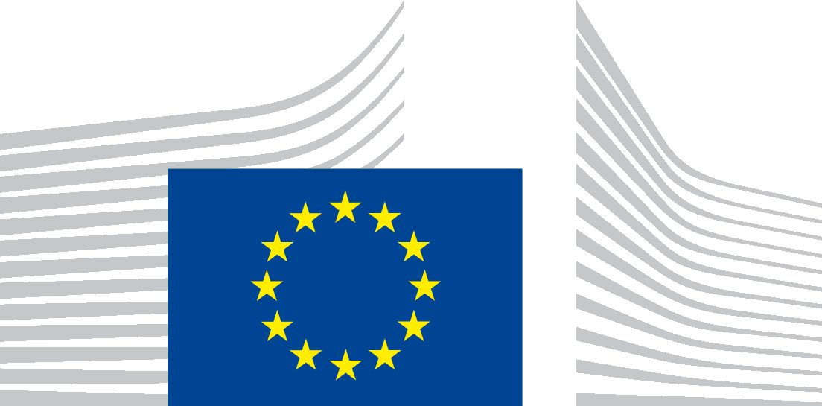 | 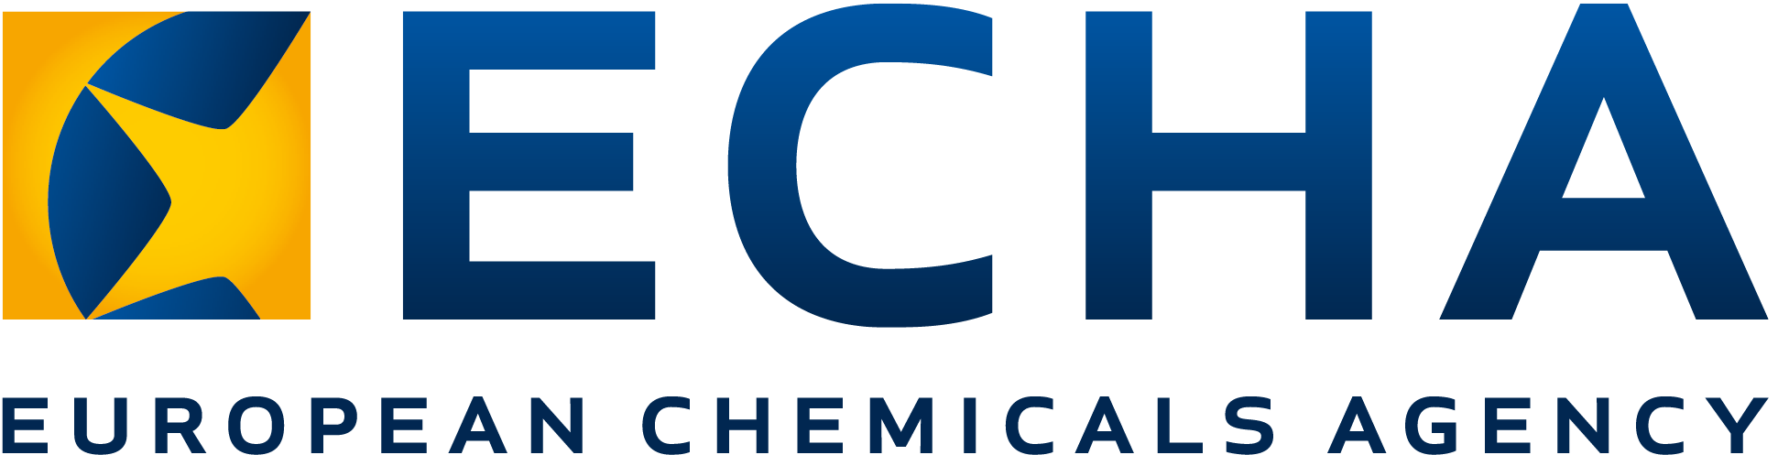EUROPEAN COMMISSION  ENVIRONMENT DIRECTORATE-GENERAL  Circular Economy and Green Growth  Sustainable Chemicals  DIRECTORATE-GENERAL INTERNAL MARKET, INDUSTRY, ENTREPRENEURSHIP AND SMES Consumer, Environmental and Health Technologies  REACH  Chemicals and Plastic Industries

Brussels,
Doc. CA/73/2020

37th Meeting of Competent Authorities
for REACH and CLP

17-18 November 2020

Concerns: Nanomaterials and REACH – An ECHA Update

Agenda Point: Information point 10

Action Requested: For information

This paper summarises the third quarter of the first year of the implementation of the nanomaterial-specific amendments in REACH. It also outlines ECHA’s ongoing activities related to development of further support to aid companies in their efforts to comply with the modified REACH Annexes in relation to nanomaterials.

ECHA Update - Introduction
ECHA has periodically informed the CARACAL of its experiences with the implementation of the updated REACH information requirements for nanoforms of substances which entered into force as of 1 January 2020. This paper provides an update of activities that have taken place since June 2020.
In June 2020, ECHA informed CARACAL of the low number of updates received, a situation that has remained since then. Therefore, the availability of specific (eco)toxicological data and safety assessments on nanoforms of substances supplied on the EU market is still very limited.
For the third quarter of 2020, ECHA’s priorities have remained focussed on giving support to companies in registering their nanoforms. ECHA has continued to provide extensive help to companies that face challenges with completing their dossiers covering nanoforms. On 28 October, ECHA published a manual "How to prepare registration dossiers covering nanoforms". This compilation of lessons learned from updates received during 2020 aims at further support registrants in completing their registrations of nanoforms of substances. New Q&A entries are regularly published on ECHA’s website. In addition, efforts have been dedicated to update the NMEG mandate to prepare this expert group for future operational needs.
ECHA received feedback from two Member States on the update provided at the June CARACAL meeting (CA_39_2020). Although the efforts to support industry are recognised, it is clear that the role of NMEG as a platform to also aid the work in implementation of REACH at Member State level, is of equal importance. ECHA foresees two meetings of the NMEG in 2021 functioning under its new mandate.

Estimating number of substances in nanoforms on the EU market
The estimate presented in ECHA’s June update to the CARACAL of 375 substances likely to exist in nanoforms on the EU market has continued to raise questions from mainly companies and trade unions. Previously ECHA provided a detailed explanation as to how this figure was derived (such as that several sources were used e.g. both national schemes as well as publically available inventories from other EU legislations). Nevertheless it appears that some companies are concerned about the reputational aspect of products being wrongly listed as ‘nano’. ECHA has invited companies and CARACAL to reflect on the list and in particular provide input as to how realistic this current estimate is. However, despite several exchanges and discussion with in particular trade unions it appears that very few of the entries are wrongly listed. This conclusion was furthermore confirmed by Eurocolour, who provided a limited number of substances which they consider not to be nano (according to the EU definition) but currently listed as such on the EUON website. Although ECHA is cross-checking the possible argumentation behind these claims, the small number of substances in question still confirms the overall view that there are around 300 substances in nanoforms on the EU market.
Consequently and comforted by the feedback from e.g. Member States, ECHA remains convinced that this list is useful as an indicator of potential substances supplied in nanoforms on the EU market and will introduce further updates where needed. ECHA will continue to communicate transparently via ECHA dissemination portal on which substances have received updates as a result of the nano-specific requirements. At the same time, ECHA welcomes further industry contributions to continue refining the list.

Received dossiers under REACH for nanoforms as of 23 October 2020

Type of submission | Submitted dossiers | Complete dossiers*
Lead dossier | 44 | 31
Member dossier | 109 | 105
Individual dossier | 4 | 4
Total | 157 | 140
*Registration dossiers for which the completeness check has been successful. As the completeness check consists of two attempts, at the moment of compiling this information, a number of dossiers are still pending the second attempt to pass the completeness check. In member dossiers that rely on the jointly submitted information in the lead dossier, completeness has been checked with respect to the Annex VI information only. It has not been verified at this point whether the Annex VII-X information that they rely on for their specific nanoforms has been submitted by the lead registrant and is complete. The number of substances for which registrations of nanoforms have been made is higher than the number of lead + individual registrations due to that some member registrants have updated their dossiers to cover nanoforms before the corresponding lead registrant has updated their dossier.

By 1 January 2020, 86 unique submissions for 34 substances covering nanomaterials were received. A further 71 unique submissions have been received so far in 2020, resulting in a total of 60 substances covering nanoforms for which registration dossiers have been submitted following the updated REACH requirements. Despite an initial high failure rate at completeness check, 89% of the submitted registrations are now complete (see table above). To date, four registration updates have been rejected following incompleteness. Out of these, one registration was already successfully updated to cover nanoforms.

Awareness raising activities
ECHA informed CARACAL in June of the awareness raising efforts that have been taken by the agency until then. Based on feedback from Member States, more is needed to increase information to the e.g. national HelpDesks. Against this background, ECHA will increase its efforts to share the experience gained so far with Member States. This was already done in a HelpNET organised workshop on 22 October with the national HelpDesks. ECHA will continue to use existing platforms such as HelpNET, the Nanomaterial Expert Group (NMEG) and CIRCABC.
ECHA provided the National Enforcement Authorities with an update of ongoing efforts to address the low number of REACH registration updates on the 28 October Forum for Exchange of Information on Enforcement meeting.
In previous updates to CARACAL, ECHA has encouraged industry to provide examples to enhance the understanding of current challenges and enable a constructive discussion. ECHA is aware of difficulties in developing such examples but would like to reiterate that they could guide further actions such as update of manuals or guidance and awareness raising efforts.

ECHA Guidance Updates for Human Health and the Environment
The calendar for updating existing guidance for nanomaterials in relation to human health and environmental endpoints is as follows:
- Update of guidance for human health (PEG consultation is ongoing; indicative timeline)
    - Stakeholder consultation (from Q2 2020 to Q2 2021)
    - Expected publication Q3 2021
- Update of guidance for environment endpoints (indicative timeline)
    - Stakeholder consultation (from Q3 2021 to Q2 2022)
    - Expected publication Q3 2022

Compliance checks, Substance Evaluation and examination of Testing Proposals
In 2021, ECHA will steer its efforts towards conducting actual dossier compliance checks of the new information requirement for nanoforms. The initial focus will be on the substance identity and characterisation of nanoforms, including justifications provided for sets of nanoforms. In addition, ECHA will examine any testing proposals received within the legal deadlines.
ECHA will also ensure, together with Member States, that the substance evaluation process effectively contributes to the implementation of the Integrated Regulatory Strategy. This entails updating the CORAP with nanoforms of substances when a substance evaluation is considered to be the most appropriate tool to generate further hazard information. Regarding the most recent ongoing or finalised substance evaluations (SEv), kindly note that MWCNT was concluded in July 2020. Furthermore, the SEv of titanium dioxide is currently undergoing decision making process.

Revision of the mandate of ECHA’s Nanomaterials Expert Group (NMEG)
The function of NMEG is well recognised by Member States. Its role in preparing decision making is proposed to be strengthened by the update of the mandate. As agreed at the previous CARACAL meeting, the draft NMEG mandate was shared for comments with CARACAL by written procedure (document CA/54/2020). The deadline for providing comments was 23 October 2020.
ECHA proposes that NMEG functions similarly to the PBT and ED Expert Groups, i.e. provides non-binding scientific and technical advice on questions related to nanomaterials or nanoforms of substances in the context of the regulatory processes under REACH, CLP and BPR, and of EUON. The objective is to improve the understanding of specific issues in order to achieve more informed and efficient discussions at Member State Committee (MSC), Risk Assessment Committee (RAC) or Biocidal Products Committee (BPC) level. As with the other Expert Groups, NMEG’s activity will however not interfere with the formal decision making process.
The need of organising NMEG meetings will be guided by demands by Member States. This requirement is to ensure that the NMEG delivers the most efficient and effective support to decision making when 1) critical scientific issues or operational issues (individual cases from e.g. REACH or BPR) have been proposed by any of the NMEG members, and 2) robust documentation (clear, comprehensive and mature enough to allow a conclusive discussion) is provided. If no topic for discussion on a specific case is received, the meeting may not be organised.
CARACAL is encouraged to consider which issues are relevant to bring for discussion at the NMEG. ECHA aims to organise the next NMEG meeting in March 2021 (date to be determined).

Get ready for new requirements for nanomaterials, ECHA news release, 8 October 2019
https://echa.europa.eu/manuals
https://euon.echa.europa.eu/search-for-nanomaterials
Status on 23 October 2020
Rejection of a registration update does not imply that the registration becomes invalid. It means that the registration does not cover the information that was submitted in the rejected dossier update; in this case the information to cover nanoforms.
https://echa.europa.eu/documents/10162/801e9ee1-1347-0072-44a5-b044510e79b5
The term ‘nanomaterial’ is associated with the particle size distribution of a substance, according to the European Commission recommendation on the definition of nanomaterial 2011/696/EU.
The term nanoform is defined in accordance with section 2.4 of Annex VI of REACH 2018/1881/EU.

