Helsinki, 28/10/2020
Doc. CA/66/2020

37th Meeting of Competent Authorities
for REACH and CLP
Competent Authorities' Session
17-18 November 2020

Concerns: Revocation of registration decisions

Agenda point: Point 9.1

Session: REACH

Action requested: Member State Competent authorities are invited to endorse the proposed approach

Revocation of registration decisions

Introduction
This paper describes the different situations under which ECHA revokes registration decisions, and how information on registration numbers that are no longer valid is available on ECHA’s website.
It also clarifies that based on the current legal text ECHA cannot revoke registration decisions of companies that fail to comply with a final evaluation decision.

Revocations
There are several requirements a registrant must meet to receive a positive registration decision with a registration number. Most of these requirements are checked upfront by ECHA, in the completeness check, before assigning a registration number. In some cases, ECHA verifies that registrants meet these requirements after they have received the registration number.

If the registration is ex-post found to not (or no longer) satisfy the requirements – for example that the registration was granted based on erroneous or incomplete information – and the registrant does not correct the situation within a given deadline, ECHA has the competence to revoke its previous registration decision and the registration number becomes invalid.

A registration is also no longer valid when the registrant notifies a cease of manufacture or import after the reception of a draft evaluation decision as per Article 50(3) of REACH.
The consequence in both cases is that the registration cannot be used to cover the manufacture and import of the substance in the EEA. Without a valid registration number, registrants cannot legally manufacture or import the substance above 1 tonne per year.

Existing revocations and revocations under development
Revocation is a powerful instrument. It is an appropriate tool to address situations where requirements for registration are not satisfied in order to maintain a level playing field among companies.
Furthermore, by acting in these situations ECHA can support the well-functioning of the joint submission, and avoid that authorities use time and resources to evaluate these registrations. Knowing which registrations are no longer valid will avoid unnecessary attempts to contact the registrant to share data, contribute to shared costs, request further information on the substance, perform SME verifications, carry out inspections, etc. Additionally, with this work, ECHA is keeping the database of active registrations and registered substances up to date.
The cases where ECHA revokes a registration decision are the following:

Wrong declaration of company size
Financial completeness of registration entails the payment of the registration fee in full. A registrant is entitled to claim SME status and benefit from a discounted registration fee if they fulfil the criteria described in the Commission Recommendation 2003/361/EC.
ECHA regularly performs a verification of the SME status claimed by registrants. If it is proven that the registrant did not fulfil the criteria to benefit from the discounted registration fee, ECHA issues a top up invoice for the difference between the paid fee and the correct fee. Additionally, an invoice with an administrative charge for the verification carried out is issued.
Article 20 of REACH gives the competence to ECHA to not grant a registration number if the dossier is financially not complete. On that basis, if a registrant does not pay the top up invoice issued by ECHA, their registration is considered incomplete due to lack of full payment of the registration fee, and ECHA revokes the registration decision. To date, 267 registration decisions have been revoked for this reason.

Ex-post completeness check
Technical completeness of registration entails the submission of all the information registrants are required to provide under Articles 10 and 12 (or Articles 17/18) of REACH and related Annexes. The technical completeness check is performed on each submitted dossier before a registration number is assigned. However, the implementation of the completeness check has changed over time, most notably when the component of manual verification of certain information by ECHA staff was introduced in 2016.
If a registration dossier is found ex-post to be technically incomplete, due to erroneous information initially provided, the completeness check process is re-initiated. The registrant is informed of the missing/incomplete information and is given a reasonable amount of time to update their registration.
If the registrant provides the requested information within the deadline, the dossier is then considered complete. Article 20 of REACH on the technical part of the completeness check, gives the competence to ECHA to not grant a registration number if the incompleteness is not resolved. On that basis, if the requested information is not provided within the deadline, ECHA revokes the registration decision.
Two campaigns of ex-post technical completeness check have been carried out to date. They took place after the introduction of the manual verification component into the completeness check process in 2016, to promote level playing field of registrants. The first campaign during 2016-2017 targeted dossiers where Annex VII-X studies had been omitted with the justification that they were ‘ongoing’ but were never updated. All the targeted dossiers where completed except two, for which the registration decisions were revoked. In a second campaign, one registration decision was revoked. No further campaigns are currently foreseen to take place.

Breach of the joint submission obligation
The Implementing Regulation 2016/9 on Joint Submission and Data Sharing clarified that ECHA should ensure that all registrants of a substance are part of the same joint submission as foreseen in Articles 11 and 19 of REACH. Following this, ECHA took actions to contact registrants that had failed to comply with the joint submission obligation (e.g. the registrant had submitted a registration dossier outside an existing joint submission, or several joint submissions were created for the same substance). ECHA requested all the registrants of the same substance to join an existing joint submission or, if one did not exist, together with other registrants, form a new one by a given deadline.

If the companies did not comply with the joint submission obligation before the deadline, their registration was revoked. In total, during the 2017-18 campaign, 37 registrations were revoked.

The Board of Appeal decision A-005-2017 considered that existing processes such as completeness or compliance check should be used instead to ensure the joint submission obligation. Accordingly, this procedure was halted and no more actions in this regard are planned.

Non-existing registrant
Registration dossiers can only be submitted by existing legal entities that (intend to) manufacture, import or act as only representatives in accordance with Articles 6 and Article 8 of REACH. If a company is found, ex-post, to not be identifiable (e.g. using meaningless contact information), ECHA may bring this to the attention of the relevant national enforcement authority for a possible verification of the actual existence of the registrant.
If the national enforcement authority (NEA) informs ECHA that a registrant is not actually identifiable on the national territory and does not fulfil the national requirements for an existing legal entity, ECHA asks the registrant via REACH-IT to update their information in order to confirm their establishment on the EU territory by a given deadline. If the establishment of the registrant is not clarified within the deadline, the registration decision is revoked.
ECHA has revoked two registration decisions of registrations submitted by unidentifiable legal entities and is expanding the process to also cover cases where registrants do not comply with national rules on company establishment.

No-longer existing registrant
As REACH registration started more than 10 years ago, it is no surprise that companies that once registered may no longer exist. In the absence of an identifiable legal entity that is responsible for the registration, ECHA can consider the registration as no longer valid.
ECHA may be informed that a company no longer meets the requirements for legal existence by co-registrants, a court administrator in charge of the liquidation proceedings of the company, or by the NEAs. Additionally, ECHA receives this information when verifying the SME status claimed by companies.
Since the valid establishment as a legal entity is according to national law, ECHA cannot act on this information on its own. The non-existence of a company (i.e. the company no longer meets the national requirement for legal existence) needs to be established by a National Authority or the NEA. This may happen upon an invitation from ECHA to check the status of a company or upon the NEA’s own initiative, when they find a company to has ceased to legally exist.
After the NEA has informed ECHA on the status of the company in accordance with national law, ECHA will contact the registrant through REACH-IT and give them the opportunity to react and clarify their situation. If no response is received, it will be considered that the company does not exist, and ECHA will revoke the registration decisions issued to that company.
ECHA is currently developing the process to handle these cases in collaboration with the NEA. Revocation of ~150 registration decisions is estimated from the information ECHA has compiled on companies that are liquidated.

UK registrants after the end of the transitional period of the UK withdrawal from the EU
After the end of the transitional period of the UK’s withdrawal from the EU on 31 December 2020, ECHA will revoke the registration decisions of registrants based in the UK that were not transferred to another company or to an only representative based in the EU-27 or the EEA. These revocations will proceed without contacting the registrant through REACH-IT, as such registrations are clearly void as a consequence of the UK’s withdrawal from the EU.

After notification of a cease of manufacture or import in accordance with Article 50(3) of REACH
According to Article 50(3) of REACH, if after the notification of a draft evaluation decision (for either dossier evaluation or substance evaluation) but before a final decision is adopted, a registrant ceases manufacture or import of a substance or article, their registration is no longer valid and they can no longer manufacture or import the substance in quantities of 1 tonne or more per year.
To date, 190 registrations are no longer valid in accordance with Article 50(3). The numbers of have grown significantly since the change in the addressee policy of ECHA which meant issuing evaluation decisions to both lead and member registrants.
Also, for these cases, the NEA and the Competent Authority of the Member State in which the registrant is located are alerted when the registration decision is revoked.

Upon requests from registrants
Sometimes registrants request ECHA to revoke their registration decision. The reasons for this request vary from having submitted the registration by mistake, to wanting to make a stronger statement after cease manufacture or import under Article 50(2) of REACH.

ECHA will decide for each request received whether they are in the position to revoke the registration decision.

Revocation not pursued
REACH foresees the compliance check (CCH) process to address non-compliant registrations. ECHA is exclusively competent for issuing decisions on non-compliant registrations whereas NEAs are exclusively competent for enforcing CCH decisions that have not been implemented.

Some NEAs have requested ECHA to consider the possibility of revoking registration decisions in order to give full effect to enforcement decisions, depriving a registrant from its right to manufacture or import a substance in the EEA rather than just nationally.
NEAs enforce the non-compliance of REACH in their own capacity, using available measures in their national legislation. However, there have been situations where the actions taken by the NEAs have not been effective in bringing the registrant to compliance. In these cases, having the possibility to revoke the registration decision would ensure compliance with REACH and strengthen the principle of ‘no data no market’. An example of such a situation is when the registrant is an Only Representative who is directly supplying downstream users in other EEA countries without importing the substance in the own country.
The Commission has clarified that REACH does not provide a legal basis for ECHA to perform this type of revocation, and that a modification of the legal text will be necessary before ECHA can revoke the registration decisions of non-compliant companies.
The Commission has foreseen in its Chemical Strategy for Sustainability the modification of the REACH Regulation needed to provide the legal competence to revoke registration decisions of non-compliant companies to ECHA by 2022.

Dissemination on the ECHA website
Information on no longer valid registrations and registrants having ceased manufacture or import, is available to the registrants in the joint submission and to the Competent Authorities in REACH-IT, and via the Interact Portal also to NEAs. This information clarifies which co-registrants still have obligations under REACH for the substance and should contribute to maintaining the registration dossier compliant and up to date.
In order to bring more transparency on the status of registrations to downstream users and the public, ECHA also publishes this information under the Information on chemicals section of its website since March 2020. In the Registered substance Factsheets, registrants are be clearly separated by those who are active; those who have ceased manufacture or import in a situation outside of Article 50(3) for which the registrant can decide at any time to resume manufacture or import; and those whose registrations are no longer valid.
The Factsheet section “Registrants/Suppliers Details” contains the names of the registrants, whereas “Administrative data” contains registration numbers. The information is disseminated as follows:
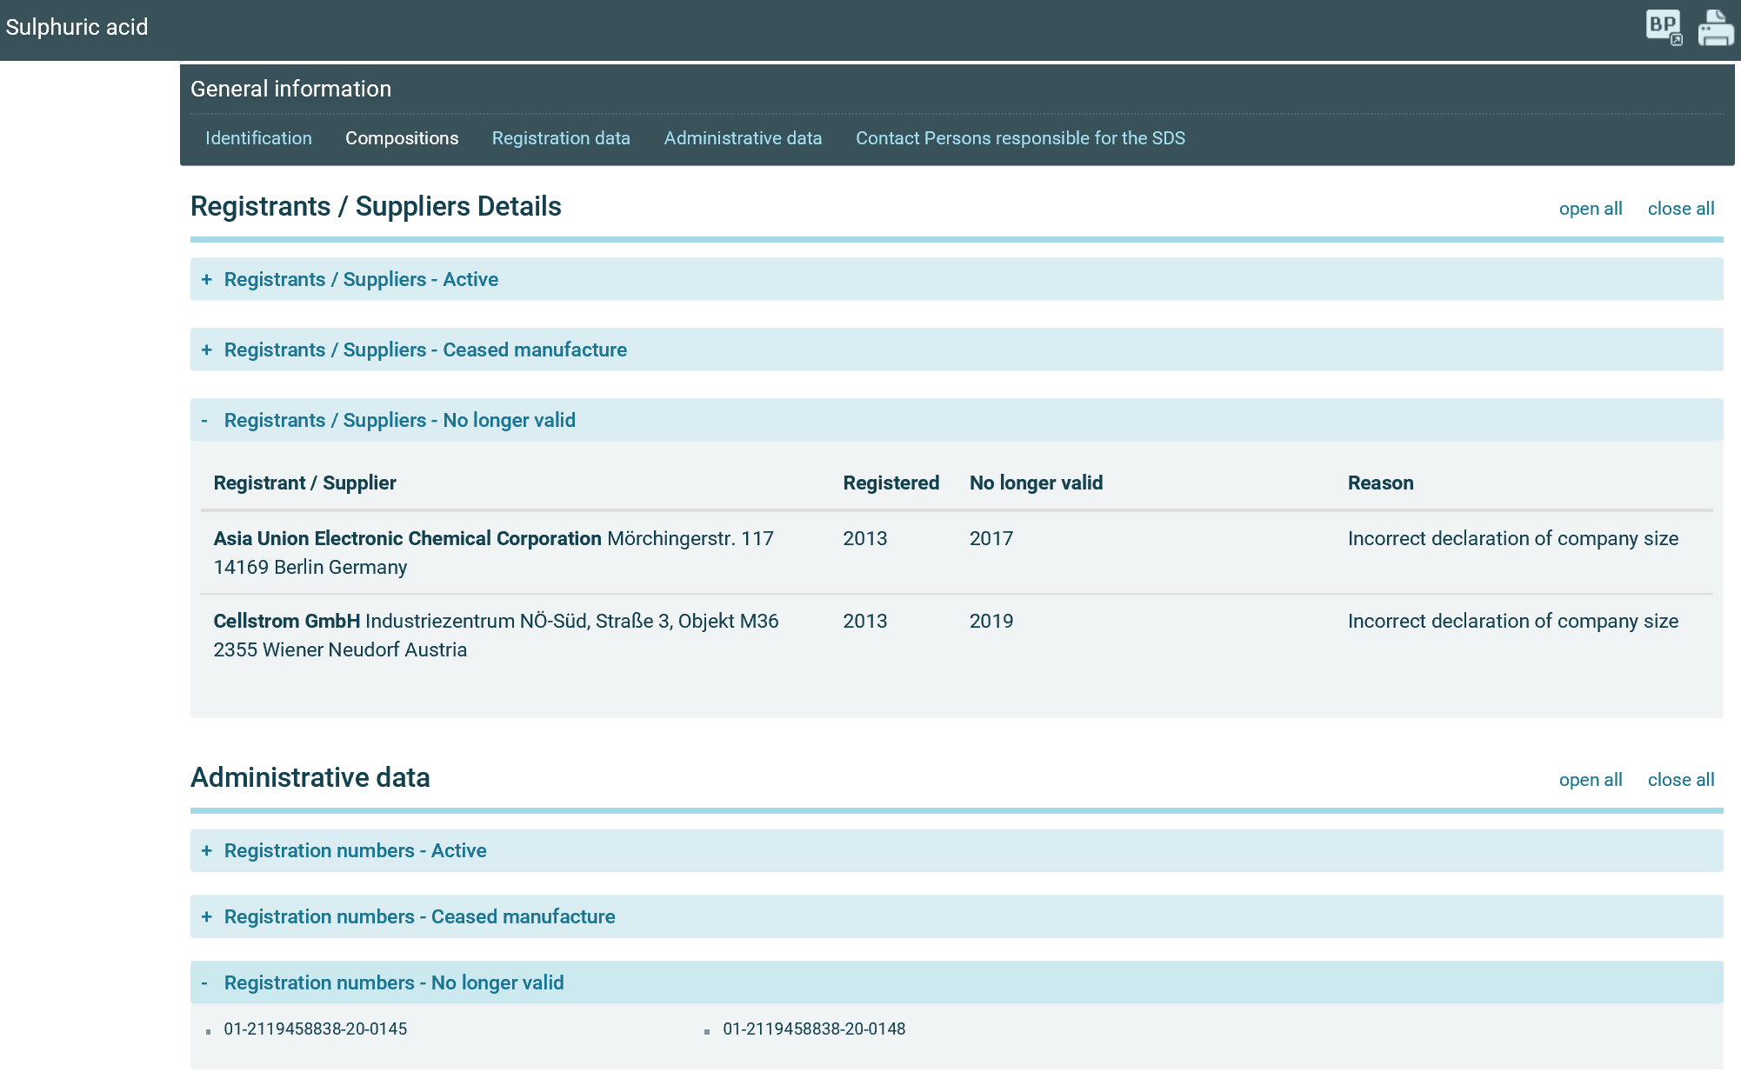

Based on the Protocol on Ireland and Northern Ireland this will not apply to registrants based in Northern Ireland.
In case the production site is in a different Member State, ECHA informs also the Competent Authority of this Member State. For Substance Evaluation cases, the Evaluating Member State is also informed.

